**Assignment -2**

Name: NITHISH KUMAR N

Reg. No.: 111519106106

**Build a python code, Assume you get temperature and humidity value and write a condition to continuously detect alarm in case of High Temperatures**.

Program:

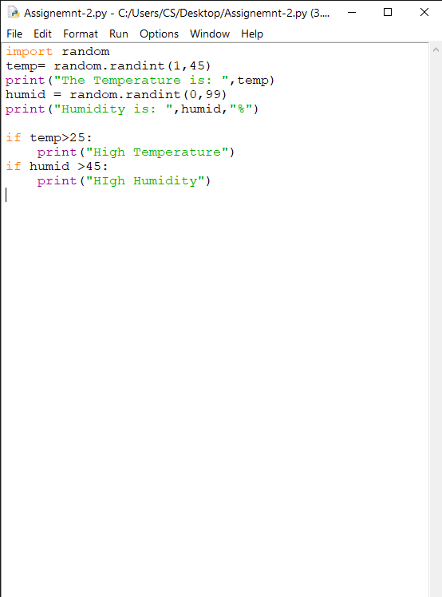import random

temp= random.randint(1,45)

print("The Temperature is: ",temp)

humid = random.randint(0,99)

print("Humidity is: ",humid,"%")

if temp>25:

print("High Temperature")

if humid >45:

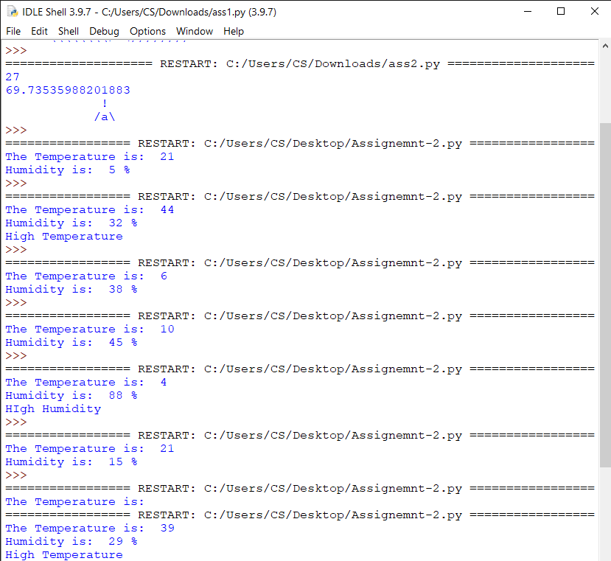 print("High Humidity")